🛠️ LAB TASKS

1️⃣ Create a file called variables.js

2️⃣ Declare and initialize variables for:
• your name
• your age
• your city

3️⃣ Print each variable using console.log()

4️⃣ Demonstrate that a let variable can be updated:
let score = 50;
console.log(score);
score = 90;
console.log(score);

5️⃣ Declare one const variable (e.g., your country) and explain in a comment why it should NOT change
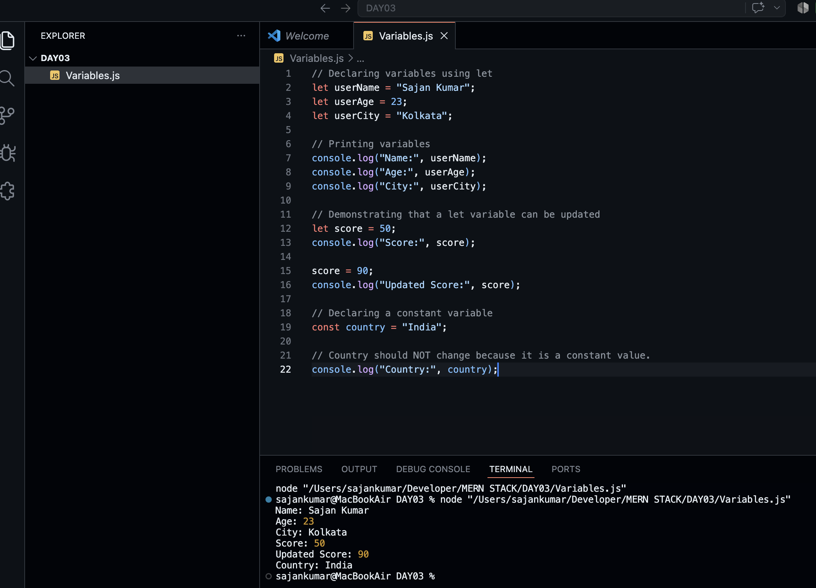
📦 DELIVERABLE — "profile.js"

Build a file that stores and prints the following using properly named variables:

✅ Name ✅ Dream Company
✅ Age ✅ Favourite Programming Language
✅ City ✅ Hobby
✅ College ✅ Goal
✅ Graduation Year ✅ Favourite App

Every single value must be printed using console.log() — no hardcoded repeated strings.
